Chapter 16, Solution 48.

Find v_{x}(s) in the circuit shown in Fig. 16.71.

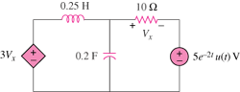

Figure 16.71
For Prob. 16.48.

Solution

First we need to transform the circuit into the s-domain.

10

3V_{x}

+ V_{x} −

s/4

5/s

+
−

+

−

V_{o}

We can now solve for V_{x}.

We should note that this represents an unstable system because at least one root has to be negative resulting in an exponential term that has a positive exponent. This is clearly the result of the dependent source.

